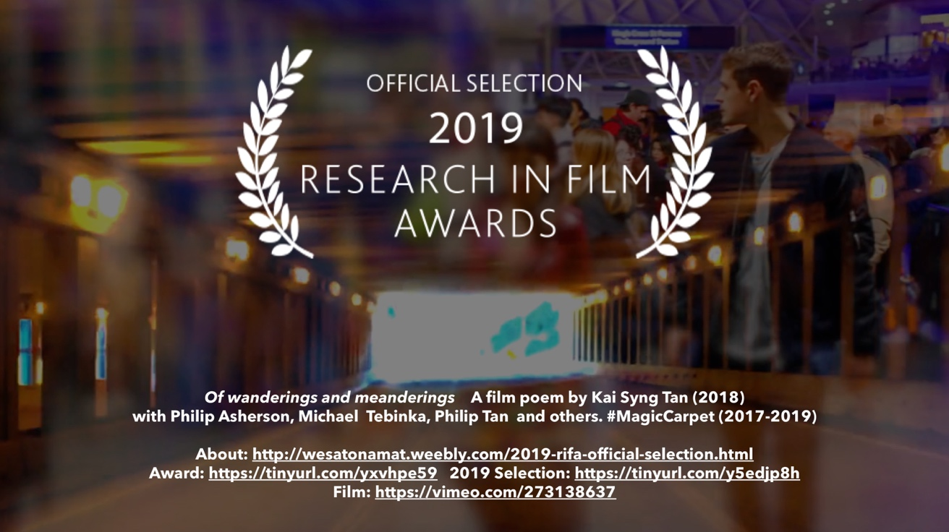

SUMMARY: A film poem by Dr Kai Syng Tan, a new Senior Lecturer at the Department of Art and Performance, Manchester School of Art, has been selected for the Best Social Media Short shortlist in the 2019 AHRC Research in Film Awards. Set up by the Arts and Humanities Research Council, this is the only film awards dedicated to celebrating and recognising arts and humanities research through film. Kai’s film, ‘Wanderings and Meanderings of the Mind and Body’ (4’30”), part of an award-winning art-science commission #MagicCarpet, is one of five films shortlisted in the category, and represents some of the very best academic filmmaking. The winners will be announced in a ceremony on 12 November at the BFI Southbank, London. Tweets: please tag @kaisyngtan @wesatonamat @AHRCpress @kingsioppn @McrSchArt #MagicCarpet

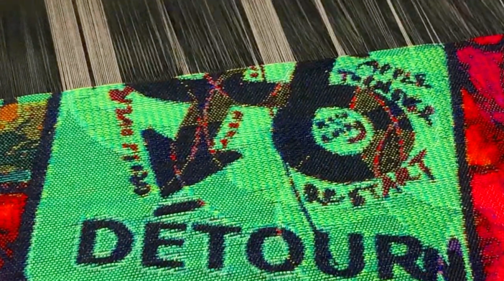

ABOUT THE AWARD: The Research in Film Awards raise the profile of films that are inspired by or are directly linked to the arts and humanities. Now in its fifth year, past RIFA winners have gone on to be nominated for other prestigious awards and festivals, or secured funding and national exposure in the media. Judged by a panel of industry experts and leading academics, the five winners are announced at a special awards ceremony at the BFI Southbank in November. Winners receive a prestigious trophy and a £2,000 prize. 2019 judges include senior cultural figures, such as Shaminder Nahal (Commissioning Editor, Channel 4), Peter Bazalgette (President of Royal Television Society, Deputy Chairman of the National Film and Television School and Non-Executive Director of ITV, Non-Executive Board Member of UK Research and Innovation), Steve Harding-Hill (Creative Director, Aardman Animations), Catherine Mallyon (Executive Director, Royal Shakespeare Company), and Jan Dalley (Arts Editor of the Financial Times).
ABOUT THE FILM: Wanderings and Meanderings of the Mind and Body (4’30”, Kai Syng Tan 2018) is of wanderings and meanderings: physical, mental, affective. Flitting in and out of consciousness. Of legible images: travelling through the Canadian Rockies; fingers combing through a tapestry; a woman with a trolley bag wandering around London. Of images that are evocative/abstract/associative/coy: A water symphony? An angry feline desiring touch? Urban decay? Of repetition and renewal? At once visceral yet intellectually-intriguing, the film bypasses language and seduces. This is a film poem that draws on themes and materials from an art-science project #MagicCarpet (2017-2019), which explores mind-wandering and how that relates to Attention Deficit Hyperactivity Disorder (ADHD) and the creative process. In many ways, it enacts the ADHD mind and mind-wandering, and is perfect for our time-poor, attention-deficit online denizens. At 4.5 minutes, Vimeo, Twitter and other social media platforms are its natural habitats. Fragmented and with no linear plot, viewers can dip in and out, but equally ‘journey-along’ with the haunting soundtrack. The film’s theme is further heightened and performed when enjoyed on mobile devices by viewers on the move. The film is a gentle invitation for people not in arts and humanities to learn more about the research behind.

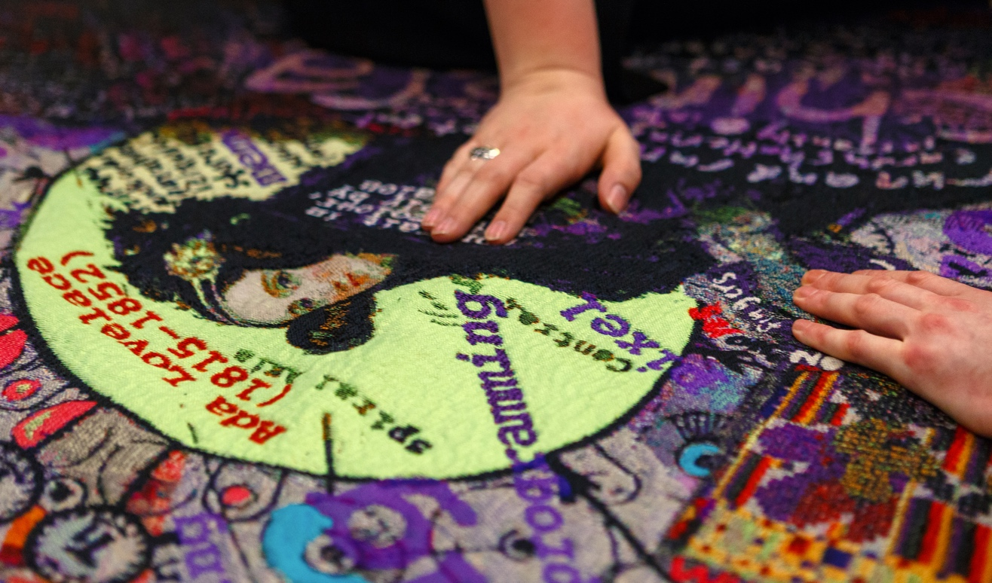

Led by an internationally-acclaimed artist Dr Kai Syng Tan (Biennale of Sydney; RUN! RUN! RUN!) in conversation with Professor of Psychiatry Philip Asherson (NIHR Senior Investigator 2017), #MagicCarpet enriches discourses on mental health and neurodiversity through practice-led creative research. #MagicCarpet was winner of the National Coordinating Centre for Public Engagement Images Award for Culture Change (2018), where judges describe it as capturing ‘vividly what it feels like to be caught up in the thrill of creating new knowledge which challenges and changes the world’. #MagicCarpet has also been nominated for the Sovereign Asian Art Award 2019, which is the largest and most established art prize in Asia Pacific. The project has reached 9500 people since 2018. Venues include Science Museum, NESTA’s People Powered Future Health, Southbank Centre, Peter Scott Gallery (Lancaster) and SOS Dyslexia Conference in San Marino. 100% of the feedback for an event agreed that #MagicCarpet extended their understanding of art-science collaboration. #MagicCarpet is ‘beautiful’ (Disability Arts Online), encouraging ‘everyone to step outside their comfort zone’ (The Psychologist). Catch it next at the Manchester Craft and Design Centre (30/1-28/3/2020) and Goethe University in Frankfurt (17/03).

Director: Kai Syng Tan | Music: Philip Tan Film | Visuals & editing: Kai Syng Tan and Michael Tebinka | With footage by: Michael Tebinka, Flanders Tapestry, Enamel Hoque, Marco Berardi, Martha McAlpine and Kai Syng Tan. | Advisor: Professor Philip Asherson. | Commissioned by Unlimited with additional support by King's College London. Commissioned by Unlimited and supported by King's College London, #MagicCarpet was an 18-month art-science project.

ABOUT KAI: Dr Kai Syng Tan FRSA SFHEA is a Senior Lecturer at Manchester School of Art, leading a new MA in Executive Arts Leadership and assisting with a new MSc of Creative and Cultural Industry Leadership programme. An artist, consultant, curator and catalyst, Kai is best known for gathering diverse and divergent bodies and bodies of knowledge to engineer spaces of ‘productive antagonisms’ (Latham & Tan 2016) across disciplinary, geopolitical and cultural boundaries, in what she calls an interdisciplinary ‘ill-disciplined’ approach (Tan & Asherson 2018). Marked by an 'eclectic style and cheeky attitude' (Sydney Morning Herald 2006), 'radical interdisciplinarity' (Alan Latham 2016) and ‘positive atmosphere’ (Guardian 2014), Kai’s performance-lectures, installation, film, critical and creative text have been featured at Biennale of Sydney, Documenta (European Artistic Research Network conference) and Tokyo Designers’ Week. Venues include Science Museum, Southbank Centre, MOMA (New York), Royal Geographical Society and Moscow’s Dom Muzyiki. Media engagement include BBC Radio3 and Fuji TV. Recognition includes San Francisco International Film Festival Golden Gate Award. Collections include Museum of London and Fukuoka Art Museum. She has taught in more than 40 higher education institutions (BA-PhD) including LASALLE College of Art (Singapore), Royal College of Art, Australian National University and Tama Art University (Tokyo).

Kai is described as ‘absolutely instrumental’ (Gregg Whelan 2015) in opening up what could be called ‘Running Studies’, which explores running as an arts and humanities discourse. This draws on her PhD research which was conducted at Slade School of Fine Art. Her Arts Council England funded Unlimited commission, #MagicCarpet, explores mind wandering, difference and neuro-diversity and has been enjoyed by more than 9000 people and said to ‘create a family for people with ADHD’ (review, The Psychologist). Co-created with disabled colleagues, the £4m Opening and Closing Ceremonies of 8th ASEAN Para Games (with Kai as Visual and Communications Director) was applauded as ‘spectacular’ by Singapore Prime Minister and ‘most inclusive’ by the Singapore Association of the Deaf. With Jen Southern and others, she helped to curate the inaugural Arts and Mobilities Network Symposium in 2018 at the Peter Scott Gallery. Kai is currently also King’s College London Artist in Residence and Visiting Fellow, UK Research and Innovation and Arts and Humanities Research Council Peer Review College Member, Music In Detention trustee, Founder and Lead of RUN! RUN! RUN!, Co-Founder and Manager of the 70-member Running Cultures Research Group, Creative and Cultural Consultant of UK Adult ADHD Network (network for mental health professionals), Advisor to PsychART (linking psychiatry, creativity and the arts, funded by Royal College of Psychiatry), and Visual and Communications Consultant for Philbeat (Singapore creative company).

MORE LINKS
- Images: https://www.dropbox.com/sh/5t58729ac497qz8/AACockMAKG0R7zkTR_0zSI-pa?dl=0
- Overview: http://wesatonamat.weebly.com/2019-rifa-official-selection.html
- Shortlist: https://ahrc.ukri.org/innovation/research-in-film-awards/the-awards/
- RIFA overview: https://ahrc.ukri.org/innovation/research-in-film-awards/
- Judges: https://ahrc.ukri.org/innovation/research-in-film-awards/judges/
- Film: https://vimeo.com/273138637
- #MagicCarpet: www.wesatonamat.weebly.com
- Kai: https://www.kcl.ac.uk/people/kai-syng-tan

